RICHMOND ORCHESTRA & CHORUS

Final Board Meeting of the Season! Monday, June 6, 2022 @7:00pm
President’s Report

I am so grateful for music to appreciate and perform, and for this organization that just keeps working through the challenges currently facing society. I’m grateful to the many volunteers- whether you have been someone winding up Brigid’s laptop cables at the end of rehearsal, or someone who has been a dedicated Board member throughout this season, I appreciate the time and effort you give to make our organization what it is.

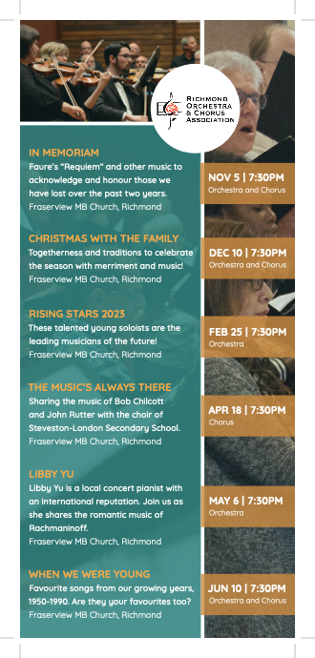
Richmond Orchestra and Chorus is much more than just those two things- orchestra and chorus. Those of us who are part of ROCA, know that well. It hasn’t been the season we would have liked and although we may be uncertain about what exactly is possible just now, we can dream and we can strive to offer our audiences and our members a performing season like the ‘good old days’, for 2022-2023!
Check out our new rack card that summarizes the offerings from Brigid and James…
We will proceed with planning for the full 2022-2023 season, and we will request that our esteemed Health and Safety committee support the members again in September to keep us on track for starting up rehearsals once again in the fall.
~~~~
I have now been in this role for almost a year, and it is indeed a busy one. Regular communication and working with Vincent, our office administrator, as well as navigating four concert recordings and all that goes with performance production has been my focus. Thank you, Vincent, for maintaining all the tasks necessary in our office- there are many nuances to the job and we appreciate your work.

I am continually supported by Bernie, our Executive Board volunteer with many hats-non-VP. Thank you, Bernie for your gentle leadership and attention to detail. I want to recognize and thank each of our Board members:
Bernie Barrett- director, interim vice president
Victor Schmidt- treasurer
Susan Stolberg- director
Alison Cole- secretary
Anatoly Brusylovskiy- director
Wilson Ng- director
Graham Hope- director
Each of these people have given many hours of time to support the performances and the goals of our organization. I know our members join me in thanking them for this work and for the thoughtful planning that goes on behind the scenes.

Brigid and James- I am so grateful to you for being the heart and drive of ROCA. Although we currently have a governance model which includes an advisory Board and active membership, it is truly you who design and maintain our themes, goals, community messaging and of course, music each year. 2021-2022 was full of amazing new challenges and creative ideas! Recording with Chris and Westcoast Recordings, creating online performances, selecting programs that suited the changing availability of members and rehearsals, offering online rehearsal options and all those many aspects of the work this year demonstrate your versatility and commitment. Brigid and James, thank you so much!

Throughout this last year, I have continued to keep my previously stated goals in mind:
- to complete our entire performance season 2021-2022, following the Covid-19 protocols set out by the PHO and our own Health and Safety committee (and modified as needed throughout the season).
- for each concert to have a land acknowledgment and a pre-production Board discussion about diversity and inclusion to ensure the content, commentary, signage etc, meets expectations.
- to modify our elementary education program so we can offer educational and enjoyable performances that represent ROCA and meet health and safety protocols.
- to make our concerts accessible to the wider community, online, and learn about our audiences’ needs and desires going forward.
- to make a profit wherever possible as we require revenue- we are seeking donations, ongoing donors and concert sponsors.
- to provide opportunities for in-person/online retreat and discussion panels where members, staff and board directors can brainstorm and discuss a vision for ROCA’s future, as we celebrate our 35th season!
I feel that these are all ‘in-progress’ or achieved goals—and I am proud to represent ROCA in our community. Highlights this year included: learning from my fellow Board members about our relationships with community partners (Richmond Community Foundation, the Food Bank, the Ukrainian Community Society); representing ROCA at the Business Excellence Awards; supporting other ROCA leaders to participate in community event such as Culture Days; celebrating (a small) profit after our four holiday concerts; making a $4000 donation to UCS this spring; speaking about Reconciliation and also singing Canadian content music in our most recent concert. Thank you for these privileges.

We are meeting tonight to start conversations about the Richmond Orchestra and Chorus- past, present and future. ROCA is a mature, non-profit organization. We have a governance model, finances and artistic leadership that are well established; however, we also do not know what the future will bring as we enter our 36th season. We will need to consider if a conductor changes, or when Board members step down or shift roles. For example, at this year’s AGM in October 2022, I will offer to accept the president nomination again, but only if we have a vice president also willing to step forward. I would like to see the partnership of president and vice president last for another year, at which time I would step down and the VP would become president. I believe this is a healthy way to create succession and collaboration on our Board. So with that said, please consider if this role would be one for you! Without volunteers to do this work, our organization will need to change how we function.
I invite your suggestions and recollections; brainstormed ideas and questions. This wonderful group of performers is a joy to be part of. I hope that we can continue to make music and make a difference in our changing and diverse community.

Thank you for your trust and your support! I hope everyone has a restful summer break, full of special memories. See you in September! Our website will be updated in August and information about registration will come out at that time.

Gratefully,

Laura Rhead
ROCA President

