PROMOTING ROCA EVENTS ON FACEBOOK

1) Find the event page on FB:

https://www.facebook.com/events/938412936233277/

Copy and paste the above link into your URL browser, or search for Richmond Orchestra & Chorus in the search bar at the top of your screen, and go to 'Events'.

2) Indicate that you are 'Going' to the event yourself:
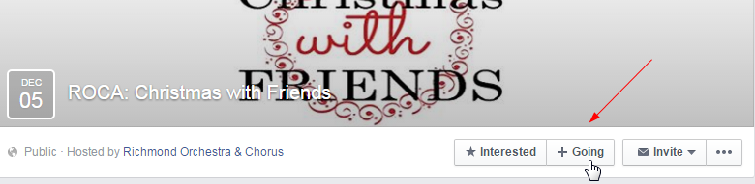

3) Share the event on your own page, which will show up on your friends' newsfeed page:
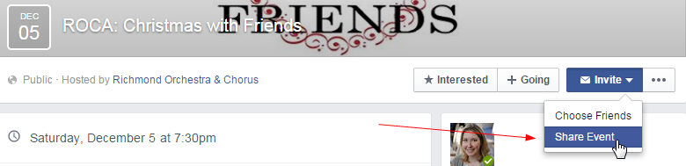

Select 'Share Event' from the 'Invite' drop down menu.

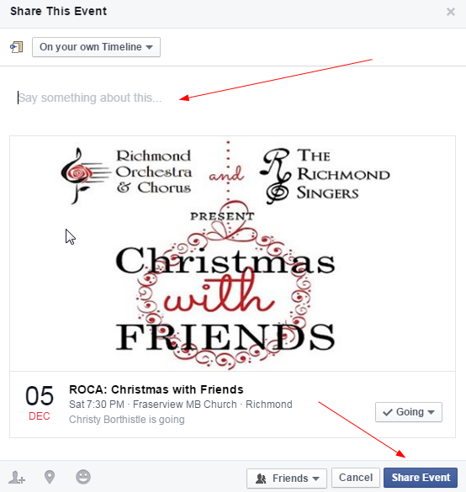

Write something about the event in the 'Say something about this…' area, and then select 'Share Event'.

4) You can also personally invite your FB friends to the event:
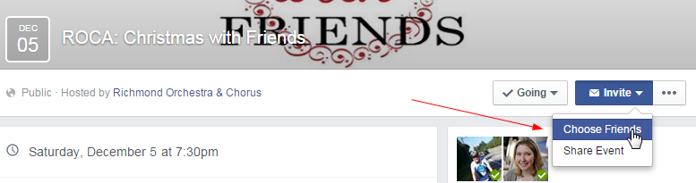

Select 'Choose Friends' from the 'Invite' drop down menu.

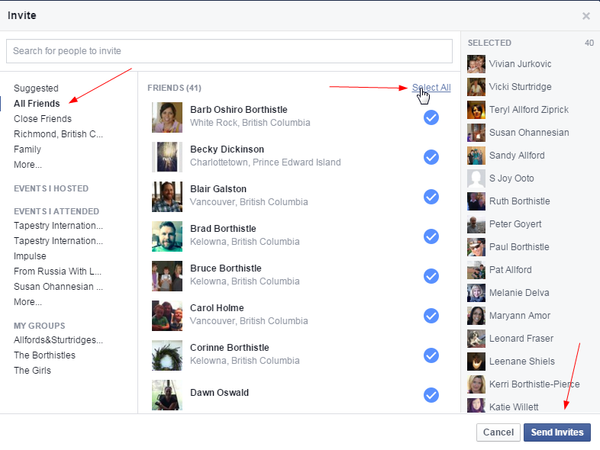

Select 'All Friends' from the left menu, and then 'Select All', or you can pick and choose who you want to invite. Once finished, press the 'Send Invites' button at the bottom right of the screen.

